**East West University**

Faculty of Science & Engineering

**CSE487: Cyber Security, Law and Ethics**

**Section**: **03**

**Summer 2022**

**🕮**

**COURSE TITLE**

**Rashedul Amin Tuhin**

Senior Lecturer

Department of Computer Science & Engineering

**East West University**

**SUBMITTED**

**TO**

**Md. Shahadat Anik Sheikh**

**ID NO: 2019-1-60-068**

Department of Computer Science & Engineering

**East West University**

**SUBMITTED**

**BY**

**November 07, 2021 | Sunday**

**SUBMISSION**

**DATE**

Week 1 Homework 1. Caesar Cipher Implementation

1. Implement Caesar Cipher in any programming language

*#encrypt cypher text  
def* cipher_encrypt(plain_text, shift):  
 encrypted = ""  
 *for* c *in* plain_text:  
 *if* c.isupper():  
 c_index = ord(c) - ord('A')  
 c_shifted = (c_index + shift) % 26 + ord('A')  
 encrypted += chr(c_shifted)  
  
 *elif* c.islower():  
 c_index = ord(c) - ord('a')  
 c_shifted = (c_index + shift) % 26 + ord('a')  
 encrypted += chr(c_shifted)  
  
 *elif* c.isdigit():  
 encrypted += str((int(c) + shift) % 10)  
  
 *else*:  
 encrypted += c  
  
 *return* encrypted

plain_text = "i love this thing."  
ciphertext = cipher_encrypt(plain_text, 7)

output:

Plain text message: i love this thing.

Encrypted ciphertext: p svcl aopz aopun.

1. Break the cipher using brute force

*#Brute force to decrypt cypher text  
def* cipher_decrypt_lower(ciphertext, key):  
 decrypted = ""  
 *for* c *in* ciphertext:  
 *if* c.islower():  
 c_index = ord(c) - ord('a')  
 c_og_pos = (c_index - key) % 26 + ord('a')  
 c_og = chr(c_og_pos)  
 decrypted += c_og  
 *elif* c.isupper():  
 c_index = ord(c) - ord('A')  
 c_og_pos = (c_index - key) % 26 + ord('A')  
 c_og = chr(c_og_pos)  
 decrypted += c_og  
 *elif* c.isdigit():  
 decrypted += str((int(c) - key) % 10)  
 *else*:  
 decrypted += c  
 *return* decrypted

*for* i *in* range(0, 26):  
 plain_text = cipher_decrypt_lower(ciphertext, i)  
 print("For key {}, decrypted text: {}".format(i, plain_text))

output:

For key 0, decrypted text: p svcl aopz aopun.

For key 1, decrypted text: o rubk znoy znotm.

For key 2, decrypted text: n qtaj ymnx ymnsl.

For key 3, decrypted text: m pszi xlmw xlmrk.

For key 4, decrypted text: l oryh wklv wklqj.

For key 5, decrypted text: k nqxg vjku vjkpi.

For key 6, decrypted text: j mpwf uijt uijoh.

For key 7, decrypted text: i love this thing. // This is the output

For key 8, decrypted text: h knud sghr sghmf.

For key 9, decrypted text: g jmtc rfgq rfgle.

For key 10, decrypted text: f ilsb qefp qefkd.

For key 11, decrypted text: e hkra pdeo pdejc.

For key 12, decrypted text: d gjqz ocdn ocdib.

For key 13, decrypted text: c fipy nbcm nbcha.

For key 14, decrypted text: b ehox mabl mabgz.

For key 15, decrypted text: a dgnw lzak lzafy.

For key 16, decrypted text: z cfmv kyzj kyzex.

For key 17, decrypted text: y belu jxyi jxydw.

For key 18, decrypted text: x adkt iwxh iwxcv.

For key 19, decrypted text: w zcjs hvwg hvwbu.

For key 20, decrypted text: v ybir guvf guvat.

For key 21, decrypted text: u xahq ftue ftuzs.

For key 22, decrypted text: t wzgp estd estyr.

For key 23, decrypted text: s vyfo drsc drsxq.

For key 24, decrypted text: r uxen cqrb cqrwp.

For key 25, decrypted text: q twdm bpqa bpqvo.

1. Attempt to break the cipher using cryptanalysis.

print("Cipher Text: ", ciphertext)  
stored_letters = {}  
  
*for* char *in* ciphertext:  
 *if* char *not in* stored_letters:  
 stored_letters[char] = 1  
 *else*:  
 stored_letters[char] += 1  
  
print(stored_letters)  
attempt = ciphertext.replace("p", "I")  
attempt = attempt.replace("a", "T")  
attempt = attempt.replace("o", "H")  
attempt = attempt.replace("s", "L")  
attempt = attempt.replace("u", "N")  
attempt = attempt.replace("z", "S")  
attempt = attempt.replace("n", "G")  
attempt = attempt.replace("v", "O")  
attempt = attempt.replace("c", "V")  
attempt = attempt.replace("l", "E")  
  
print("Plain Text: ", attempt)

output:

Cipher Text: p svcl aopz aopun.

{'p': 3, ' ': 3, 's': 1, 'v': 1, 'c': 1, 'l': 1, 'a': 2, 'o': 2, 'z': 1, 'u': 1, 'n': 1, '.': 1}

Plain Text: I LOVE THIS THING.

Week 1 Homework 2. MTU is Maximum Transmission Unit

1. Write a computer program to discover the actual MTU size of your communication network.

*import* socket  
*class* IN:  
 IP_MTU = 14  
 IP_MTU_DISCOVER = 10  
 IP_PMTUDISC_DO = 2  
  
  
s = socket.socket(socket.AF_INET,socket.SOCK_DGRAM)  
hostName = "103.170.175.60"  
Port = 9999  
s.connect((hostName, Port))  
s.setsockopt(socket.IPPROTO_IP, IN.IP_MTU_DISCOVER, IN.IP_PMTUDISC_DO)  
MTU_Size = 1488  
*try*:  
 s.send(b'#' * 44 * MTU_Size)  
*except* socket.error:  
 print('The message did not make it')  
 option = getattr(IN, 'IP_MTU', 14)  
 print('MTU:', s.getsockopt(socket.IPPROTO_IP, option))  
*else*:  
 print('My network supports', MTU_Size, 'big packets!')

output: My network supports 1488 big packets!

Usuing CMD:

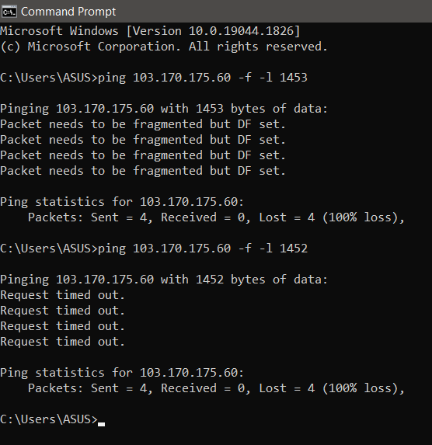

We have to take into account the size of the TCP/IP header, which can range between 20-60 bytes. The header size varies according to the transmission media.

My Point-to-Point Protocol over Ethernet (PPPoE) header takes up 8 bytes in size, while the IPv6 header accounts for 40 bytes in size. So, the size of my TCP/IP header is 48 bytes (40+8).

Let’s take the packet size that gave us the ping reply (1452 bytes) and add it to the header size (48 bytes).

That leads us to the real MTU size, which is 1500 bytes, the common Ethernet MTU.

Week 2 Homework 3. Implement at least five cipher algorithms of different types.

1. Monoalphabetic Cipher

key_dict = {  
 'a': 'm',  
 'b': 'n',  
 'c': 'b',  
 'd': 'v',  
 'e': 'c',  
 'f': 'x',  
 'g': 'z',  
 'h': 'a',  
 'i': 's',  
 'j': 'd',  
 'k': 'f',  
 'l': 'g',  
 'm': 'h',  
 'n': 'j',  
 'o': 'k',  
 'p': 'l',  
 'q': 'p',  
 'r': 'o',  
 's': 'i',  
 't': 'u',  
 'u': 'y',  
 'v': 't',  
 'w': 'r',  
 'x': 'e',  
 'y': 'w',  
 'z': 'q',  
 ' ': ' ',  
}  
  
  
*def* get_key(value):  
 *for* key, val *in* key_dict.items():  
 *if* (val == value):  
 *return* key  
  
  
*def* monoalphabetic_encrypt(word):  
 c = ''  
 *for* i *in* word:  
 i = key_dict[i]  
 c += i  
 *return* c  
  
  
*def* monoalphabetic_decrypt(word):  
 c = ''  
 *for* i *in* word:  
 i = get_key(i)  
 c += i  
 *return* c  
  
  
encryptText = monoalphabetic_encrypt("rock and roll")  
print(encryptText)  
print(monoalphabetic_decrypt(encryptText))

1. Playfair Cipher

key = input("Enter the key: ")  
key = key.replace(" ", "")  
key = key.upper()  
  
  
*def* matrix(x, y, initial):  
 *return* [[initial *for* i *in* range(x)] *for* j *in* range(y)]  
  
  
result = list()  
*for* c *in* key: *# storing key  
 if* c *not in* result:  
 *if* c == 'J':  
 result.append('I')  
 *else*:  
 result.append(c)  
flag = 0  
*for* i *in* range(65, 91): *# storing other character  
 if* chr(i) *not in* result:  
 *if* i == 73 *and* chr(74) *not in* result:  
 result.append("I")  
 flag = 1  
 *elif* flag == 0 *and* i == 73 *or* i == 74:  
 *pass  
 else*:  
 result.append(chr(i))  
k = 0  
my_matrix = matrix(5, 5, 0) *# initialize matrix  
for* i *in* range(0, 5): *# making matrix  
 for* j *in* range(0, 5):  
 my_matrix[i][j] = result[k]  
 k += 1  
  
  
*def* locindex(c): *# get location of each character* loc = list()  
 *if* c == 'J':  
 c = 'I'  
 *for* i, j *in* enumerate(my_matrix):  
 *for* k, l *in* enumerate(j):  
 *if* c == l:  
 loc.append(i)  
 loc.append(k)  
 *return* loc  
  
  
*def* encrypt(): *# Encryption* msg = str(input("ENTER MSG:"))  
 msg = msg.upper()  
 msg = msg.replace(" ", "")  
 i = 0  
 *for* s *in* range(0, len(msg) + 1, 2):  
 *if* s < len(msg) - 1:  
 *if* msg[s] == msg[s + 1]:  
 msg = msg[:s + 1] + 'X' + msg[s + 1:]  
 *if* len(msg) % 2 != 0:  
 msg = msg[:] + 'X'  
 print("CIPHER TEXT:", end=' ')  
 *while* i < len(msg):  
 loc = list()  
 loc = locindex(msg[i])  
 loc1 = list()  
 loc1 = locindex(msg[i + 1])  
 *if* loc[1] == loc1[1]:  
 print("{}{}".format(my_matrix[(loc[0] + 1) % 5][loc[1]], my_matrix[(loc1[0] + 1) % 5][loc1[1]]), end=' ')  
 *elif* loc[0] == loc1[0]:  
 print("{}{}".format(my_matrix[loc[0]][(loc[1] + 1) % 5], my_matrix[loc1[0]][(loc1[1] + 1) % 5]), end=' ')  
 *else*:  
 print("{}{}".format(my_matrix[loc[0]][loc1[1]], my_matrix[loc1[0]][loc[1]]), end=' ')  
 i = i + 2  
  
  
*def* decrypt(): *# decryption* msg = str(input("ENTER CIPHER TEXT:"))  
 msg = msg.upper()  
 msg = msg.replace(" ", "")  
 print("PLAIN TEXT:", end=' ')  
 i = 0  
 *while* i < len(msg):  
 loc = list()  
 loc = locindex(msg[i])  
 loc1 = list()  
 loc1 = locindex(msg[i + 1])  
 *if* loc[1] == loc1[1]:  
 print("{}{}".format(my_matrix[(loc[0] - 1) % 5][loc[1]], my_matrix[(loc1[0] - 1) % 5][loc1[1]]), end=' ')  
 *elif* loc[0] == loc1[0]:  
 print("{}{}".format(my_matrix[loc[0]][(loc[1] - 1) % 5], my_matrix[loc1[0]][(loc1[1] - 1) % 5]), end=' ')  
 *else*:  
 print("{}{}".format(my_matrix[loc[0]][loc1[1]], my_matrix[loc1[0]][loc[1]]), end=' ')  
 i = i + 2  
  
  
*while* (1):  
 choice = int(input("\nChosse one of them\n \t1.Encryption \n \t2.Decryption \n \t3.EXIT\nEnter your option: "))  
 *if* choice == 1:  
 encrypt()  
 *elif* choice == 2:  
 decrypt()  
 *elif* choice == 3:  
 exit()  
 *else*:  
 print("Choose correct choice")

output:

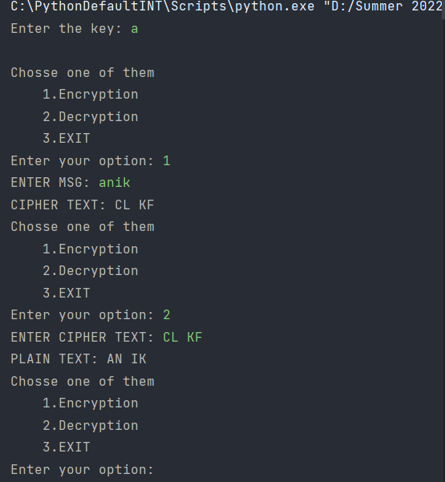

1. Substitution Cipher

*import* random  
  
alphabet = 'abcdefghijklmnopqrstuvwxyz.,! '  
key = 'nu.t!iyvxqfl,bcjrodhkaew spzgm'  
plaintext = "Hey, this is really fun!"  
  
  
*def* makeKey(alphabet):  
 alphabet = list(alphabet)  
 random.shuffle(alphabet)  
 *return* ''.join(alphabet)  
  
  
*def* encrypt(plaintext, key, alphabet):  
 keyMap = dict(zip(alphabet, key))  
 *return* ''.join(keyMap.get(c.lower(), c) *for* c *in* plaintext)  
  
  
*def* decrypt(cipher, key, alphabet):  
 keyMap = dict(zip(key, alphabet))  
 *return* ''.join(keyMap.get(c.lower(), c) *for* c *in* cipher)  
  
  
cipher = encrypt(plaintext, key, alphabet)  
  
print(plaintext)  
print(cipher)  
print(decrypt(cipher, key, alphabet))

output:

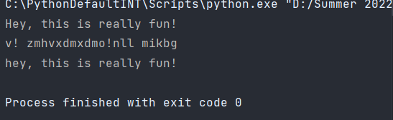

1. Transposition Cipher

*import* pyperclip  
  
*def* main():  
 msg = 'Transposition Cipher'  
 key = 10  
 ciphertext = encryptMessage(key, msg)  
  
 print("Cipher Text is: ", ciphertext, '|', pyperclip.copy(ciphertext))  
  
*def* encryptMessage(key, message):  
 ciphertext = [''] * key  
  
 *for* col *in* range(key):  
 position = col  
 *while* position < len(message):  
 ciphertext[col] += message[position]  
 position += key  
 *return* ''.join(ciphertext)  
  
*if* __name__ == '__main__':  
 main()

output: Cipher Text is: Tiroann sCpiopshietr

1. Vigenère cipher

*def* generateKey(string, key):  
 key = list(key)  
 *if* len(string) == len(key):  
 *return* (key)  
 *else*:  
 *for* i *in* range(len(string) - len(key)):  
 key.append(key[i % len(key)])  
 *return* ("".join(key))  
  
  
*def* encryption(string, key):  
 encrypt_text = []  
 *for* i *in* range(len(string)):  
 x = (ord(string[i]) + ord(key[i])) % 26  
 x += ord('A')  
 encrypt_text.append(chr(x))  
 *return* ("".join(encrypt_text))  
  
  
*def* decryption(encrypt_text, key):  
 orig_text = []  
 *for* i *in* range(len(encrypt_text)):  
 x = (ord(encrypt_text[i]) - ord(key[i]) + 26) % 26  
 x += ord('A')  
 orig_text.append(chr(x))  
 *return* ("".join(orig_text))  
  
  
*if* __name__ == "__main__":  
 string = input("Enter the message(Use only upper case): ")  
 keyword = input("Enter the keyword: ")  
 key = generateKey(string, keyword)  
 encrypt_text = encryption(string, key)  
 print("Encrypted message:", encrypt_text)  
 print("Decrypted message:", decryption(encrypt_text, key))

output:

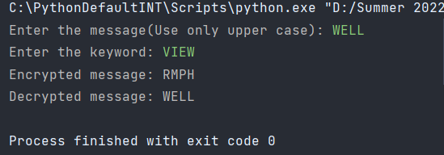

Week 2 Homework 4. Pass up to level 14 in Bandit Wargame

